**Curriculum Vitae**

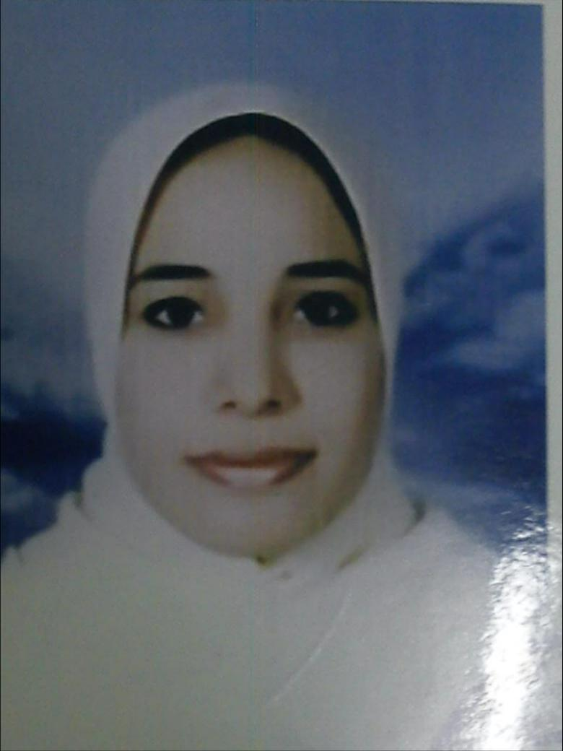

**Personal Data**:

* First name: Abeer
* Middle name: Houssein
* Last name: Ali
* Mobile: +2 01007078382
* E-mail: abeeryaa[@yahoo.com](mailto:hamdy20002000m@yahoo.com)
* Date of birth: 30, August,1980
* Nationality: Egyptian
* Address: Egypt-Assiut- Assiut University- Assiut University Hospitals- radio diagnosis Department.
* Languages: Arabic excellent

English very good

French fair

* **Current Position** :

- Assistant lecturer of radio diagnosis and interventional radiology

, Assiut University Hospitals.

* **Positions held** :

**House officer** at Assiut University Hospital (March 2004- February 2005).

**Resident** in Physical Medicine, Radio-diagnosis Department, Assiut University Hospitals (March 2005-February 2008).

**Specialist of** Radio-diagnosis in ministry of health and population ( jun 2008- February 2009).

**Demonstrator**, Physical Medicine, Radio-diagnosis Department, Assiut University (March 2009-July 2009).

**Assistant lecturer** of Physical Medicine, Radio-diagnosis (July 2009-till now).

* **Medical degrees received:**

- Bachelor of Medicine and Surgery (MBBch) from Faculty of Medicine, Assiut University, 2003.

- Master degree in radiology (MSc) from radiology department, Assiut University, October 2008.

* **Experiences:**

-The rotating House officer period (1/3/04-28/2/05) it was divided into two months in each of the following departments: Gynaecology & Obstetrics, General Surgery, Paediatrics, Internal Medicine, Anaesthesiology, Traumatology, Causalities Unit & Emergency Unit.

-The residency period (1/3/05-29/2/08) during which I worked in arotatory pattern all over all units of radiology department, my link as a junior continued for 6 months till 31/08/05. I'm working in all units of our department including main hospital, trauma unit, emergency unit, pediatric hospital.

-since joining radiology department I have gaining extensive clinical, radiological and intraoperative follow up experience for my cases to confirm my radiological diagnosis.

* + **Teaching activities:**

- Supervising and directing residents since 2009

* **Training courses & conferences :**

-Annual scientific conference of our department, December 2009, state of art of MSCT application, now we have 4 MSCT machines (16&64) Toshiba, GE, Seimens and 256 philips will be available within few months in recently prepared specialized cardiac center that is expected to be one of the largest centers in Egypt regarding capacity and financial funding.

-30th annual conference of faculty of medicine April 2014.

* **Research Activities**:

Publication of one research **(One-shot MR and MDCT arthrography of shoulder lesions with arthroscopic correlation**), in the Egyptian Journal of Radiology and Nuclear Medicine, Volume 44, Issue 2, June 2013, Pages 273–281**.**

* **Social activities:**

-Our hospitals offer both free and payed services for the help of society for example the main hospital only has about 2200 beds, millions of people travel to our hospitals seeking medical advice, it is the largest hospitals that were gathered in a medical village allover Egypt furthermore the most famous in upper Egypt over many years and up till now and also one of the five famous medical centers allover Egypt (Cairo, Almansoura, Assiut, Ain Shams and Alexandria).

- sharing in Medical convoys directed for poor villages.